Pimpri Chinchwad Education Trust’s
Pimpri Chinchwad College of Engineering

Sector No. 26, Pradhikaran, Nigdi, Pune 411044

An Autonomous Institute Approved By AICTE and Affiliated To SPPU, Pune

DEPARTMENT OF INFORMATION TECHNOLOGY


Software Engineering and Modelling Laboratory Mini Project Report
of
T. Y. B. Tech
Academic Year: 2025-26
Semester - I

on

MSRTC Bus Booking & Tracking System

By

PRN | Name of the Student
123B1F097 | Atharva Thakur
123B1F090 | Om Shelke
123B1F103 | Pradeep Waghmode

CERTIFICATE

This is to certify that the project report entitled MSRTC Bus Booking & Tracking System, submitted by Atharva Thakur, Om Shelke, Pradeep Waghmode in partial fulfillment of the requirements for the award of the degree Bachelor of Technology in Information Technology, is a record of original work carried out under the supervision of Mrs. Mukta Jamage. This project report has not been previously submitted to any other institute or university for the award of any degree or diploma.

Mrs. Mukta Jamage Prof. Dr. Jayashree Katti
Project Guide HOD IT

INDEX
Sr. No. | Chapters | Page No
 | Introduction  1.1 Project background and Motivation  1.2 Application Domain and SDG  1.3 Aim and Objectives | 1-2
 | System Study  2.1 Existing System  2.2 Limitation of existing system  2.3 Proposed System  2.4 Problem Title | 3-4
 | System Requirements Specification (SRS)  3.1 Functional and Non functional requirement traceability matrix(RTM)  3.2 Requirement prioritization- Kanno diagram | 5-6
 | System Design  4.1 Selection of appropriate SDLC model and its justification  4.2 Use case diagram  4.3 Class Diagram  4.4 Data Flow Diagram  4.5 Activity Diagram | 7-11
 | System Implementation  5.1 Module Description  5.2 Data set collection  5.3 Pseudocode and Screenshot | 11-20
 | Testing and Deployment  6.1 Manual test cases for RTM listed requirements (from chapter 3)  6.2 Deployment Strategies | 21-22
 | Result and Discussion | 23-24
 | References | 25

Chapter 1
Introduction

1.1 Project Background and Motivation
Public bus transport booking and tracking in India has historically faced significant obstacles, ranging from manual ticket distribution and seat allocation to limited access to real-time information. Passengers – especially those in rural areas and during peak seasons – encounter long queues, confusion about seat status, and last-minute changes. The old systems are paper-based or operate with basic terminals, often lacking reliable integration with digital payment or live bus tracking functionalities.​
In today’s era, the widespread use of smartphones and web applications presents a clear opportunity for transformation in public transport ticketing and passenger information. End-to-end digital platforms for bus reservation, seat selection, payment integration, and real-time tracking can deliver substantially improved passenger convenience, more reliable journeys, and streamlined operations for transport authorities.​

1.2 Challenges in India’s Existing Bus Booking
- Manual ticket counters create long queues and wasted passenger time, especially in busy cities and during festival or vacation periods.
- Inefficient seat allocation frequently leads to booking errors and poor user experiences, with several passengers often unsure of their allocated seats or encountering double-bookings.
- Real-time seat and location information is generally lacking. Passengers rarely receive live updates and may be unaware of bus delays, diversions, or last-minute cancellations.
- Payment and live location integration remains challenging. Many traditional systems lack online gateway support or GPS-based tracking, leaving both staff and passengers without timely updates and secure payment options.
- Service accessibility issues. The digital divide in India means that not all users can access or navigate poorly designed transport portals.​

1.3 Application Domain and SDG Alignment
This mini project falls squarely within the public transport and smart mobility domain, focusing on digital services for mass transit and intercity bus operations.
It aligns closely with United Nations Sustainable Development Goal (SDG) 11: “Sustainable Cities and Communities”—particularly the target for “access to safe, affordable, accessible, and sustainable transport systems for all,” including vulnerable populations and those in remote areas. By streamlining booking and real-time tracking, the project advances digital inclusion, supports resource efficiency, and helps reduce urban travel stress.​

1.4 Aim and Objectives
- Develop a user-friendly, web-based platform for booking MSRTC (Maharashtra State Road Transport Corporation) bus tickets, seat selection, and payment.
- Enable real-time seat availability and immediate booking confirmation, eliminating booking conflicts and uncertainties.
- Integrate digital payment options, supporting UPI and other contemporary systems for secure transactions.
- Provide live tracking of bus locations via station master and automated updates, increasing safety and journey confidence for passengers.
- Ensure mobile responsiveness for on-the-go access and usability across devices.
- Lay groundwork for future enhancements: scalability to mobile apps, SMS notifications, cloud deployment, and analytics for operators.

Chapter 2
System Study
2.1 Existing System
Traditional MSRTC and many other public bus systems in India still rely heavily on offline, paper-based ticketing or basic web interfaces. Passengers often need to physically visit depots, stand in queues, and depend on staff for every booking and inquiry. Most existing systems lack live seat visualization, instant digital payments, real-time bus tracking, and systematic email notifications.​

2.2 Limitations of the Existing System
- Manual booking and seat checking: Passengers queue at counters or limited websites and must manually confirm seat availability, often resulting in duplication, booking conflicts, and slow processes.
- No automated, interactive seat layout: There is rarely a seat map or visual seat selection feature; users are assigned seats by staff or via simple dropdowns with no real feedback on booking conflicts.
- Lack of digital payment and confirmation: Most transactions require cash, and tickets are printed on paper, losing out on UPI, credit/debit, or wallet payments, and providing no digital receipts or confirmations.
- No bus tracking for users: Passengers have no way to check the live location of buses, leading to confusion and anxiety, especially in cases of delays, diversions, or last-minute changes.​
- No automated notifications: Updates regarding bookings, cancellations, or changes in bus location or schedule are not delivered proactively to the user.

2.3 Proposed System
The new system is built as a responsive, user-friendly web application using the Flask framework. Key features include:
- User registration and authentication: Allows secure sign-up and login for customers and station masters, with role-based dashboard access.
- Real-time, grid-based seat booking interface: Users see a live seat map and select available seats with instant feedback if a seat is taken.
- UPI QR code and online payment confirmation: Supports modern digital payments with immediate transaction feedback and e-receipt.
- Automatic email confirmation: Sends detailed confirmation emails after every successful booking and payment, enhancing trust and record-keeping.
- Station master live bus location updates: Empowers staff to update a bus's GPS location and enables passengers to check the real-time position of their bus before and during their trip.
- Mobile- and desktop-friendly design: Ensures broad accessibility, even for users on the move.

2.4 Problem Definition/Title
Design and implement a web-based MSRTC Bus Tracking & Booking System for digital ticketing, combining instant interactive seat selection, secure cashless payment, automated notifications, and real-time bus location tracking, thereby modernizing and streamlining ticketing and passenger information flow for public transport in Maharashtra.
Chapter 3
System Requirement Specification (SRS)
3.1 Functional and Non-Functional Requirements
Requirement ID | Functional Requirements
FR1 | User authentication (sign up/in/log out)
FR2 | Booking: Bus selection and seat selection
FR3 | Real-time booked seat updating
FR4 | Online payment integration (UPI QR)
FR5 | Email confirmation notification
FR6 | Station master can update live bus location
FR7 | User can track bus status
FR8 | Display total fare dynamically

Requirement ID | Non-Functional Requirements
NFR1 | Web-based, responsive UI
NFR2 | Secure session and input validation
NFR3 | Fast real-time seat booking response
NFR4 | Low downtime and high reliability

3.2 Requirement Traceability Matrix (RTM)
Req ID | Module | Satisfied (Y/N)
FR1 | Auth | Y
FR2 | Booking | Y
FR3 | Booking, API | Y
FR4 | Payment | N
FR5 | Payment/Email | Y
FR6 | StationMaster | Y
FR7 | Track | Y
FR8 | Booking | Y

3.3 Requirement Prioritization - Kanno Diagram (Brief Description)
- Must-have: User authentication, seat selection, payment, confirmation mail, live booking update
- Should-have: Live tracking, QR integration
- Nice-to-have: GUI improvements, enhanced analytics

Chapter 4
System Design
4.1 SDLC Model Selected: Agile-Spiral
Justification:
The Agile-Spiral hybrid model is best suited for this bus booking and tracking system project because it leverages the strengths of both Agile and Spiral methodologies to effectively address the project’s dynamic and complex requirements.
- Frequent Feedback Cycles: Agile’s iterative sprints enable regular user and stakeholder feedback. This is crucial for incorporating evolving client needs, such as real-time updates for bus tracking, adaptable seat booking, and enhancements to the user interface, as seen in your project’s continuous feature improvements.
- Rapid Deployment and Incremental Delivery: Agile allows delivering functional parts of the system frequently so that users get early access to core functionalities like registration, booking, and payment, ensuring early user engagement and validation.
- Risk Management and Structured Refinement: The Spiral model’s focus on systematic risk analysis mitigates uncertainties especially in critical aspects such as integrating Razorpay payments and managing accurate, real-time GPS updates with both manual and automated inputs. This helps reduce potential project failures or costly rework.
- Flexibility for Changing Requirements: Both Agile and Spiral embrace change. Your project naturally benefits from this adaptability, given features like automated bot updates for bus locations and evolving seat reservation logic.
- Customer Involvement: Spiral emphasizes strong stakeholder engagement at each phase, complementing Agile’s collaborative culture, which aligns well with the system’s need for feedback from passengers and station masters.
Why Not Other Models:
- Waterfall: A rigid, sequential Waterfall approach limits flexibility and late-stage requirement changes, unsuitable for projects needing real-time data tracking and continuous feature evolution.
- V-Model: While strong on verification and validation, it shares Waterfall’s inflexibility and slower adaptation, not ideal for your project’s iterative development needs.
- Prototype Model: Though useful for early feedback, it lacks comprehensive risk management and structured progression, which Spiral provides.
- RAD (Rapid Application Development): Focuses on rapid prototyping but may lack the thorough risk mitigation and disciplined iterative refinements essential for integrating complex subsystems like payment gateways and real-time GPS tracking.

4.2 Use Case Diagram
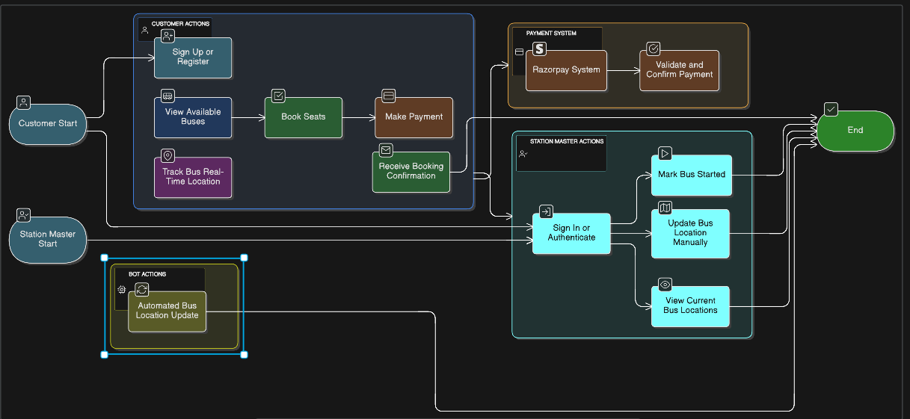
Fig. 4.2 Use Case Diagram of MSRTC Bus Booking & Tracking System
4.2.1 Use Cases
- Sign Up / Register (Customer/User)
- Sign In / Authenticate (Customer/User, Station Master)
- View Available Buses (Customer/User)
- Book Seats (Customer/User)
- Make Payment (Customer/User via Razorpay)
- Receive Booking Confirmation (Customer/User via email)
- Track Bus Real-Time Location (Customer/User)
- Mark Bus Started (Station Master)
- Update Bus Location Manually (Station Master)
- Automated Bus Location Update (AutoStationMasterBot)
- View Current Bus Locations (Station Master)
- Validate and Confirm Payment (System with Razorpay)

4.3 Class Diagram
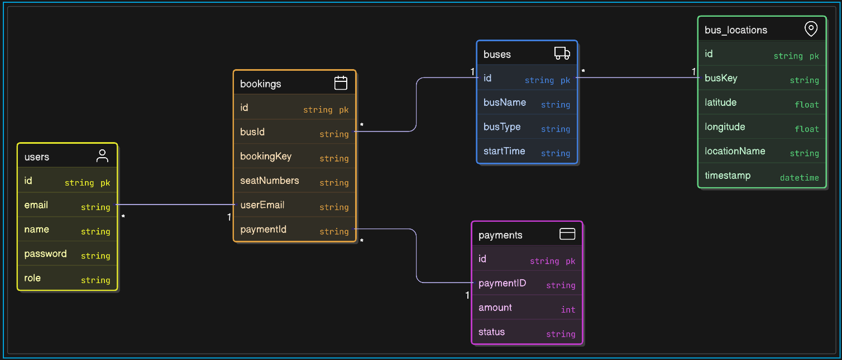
Fig. 4.3 Class Diagram of MSRTC Bus Booking & Tracking System
The class diagram for your bus booking and tracking system project describes the main structural entities involved and their relationships:
- User: Represents all users including customers and station masters. Attributes include email, name, password, and role. It handles authentication and role-based access.
- Bus: Contains details of buses such as busName, busType, and startTime. It manages bus-related information.
- BusLocation: Stores real-time geographical data of buses with attributes like busKey (derived from bus name, type and start time), latitude, longitude, locationName, and timestamp. It supports updating and retrieving current bus locations.
- Booking: Represents seat reservations. Attributes include bookingKey (bus key), seatNumbers, and userEmail. It manages seat availability and booking confirmation.
- Payment: Handles payment transactions, with paymentID, amount, and status. This class integrates with the Razorpay gateway for payment processing and verification.
Relationships:
- One User can have multiple Bookings.
- Each Booking corresponds to one Bus.
- A Bus has multiple BusLocation entries that track its live updates.
- Each Booking is linked to one Payment for transaction confirmation.

4.4 DFD (Level 0, 1 where applicable)
- Level 0: Input - user action; Process - booking, payment; Output - confirmation;
- Level 1: Covers seat availability check, payment validation, email send
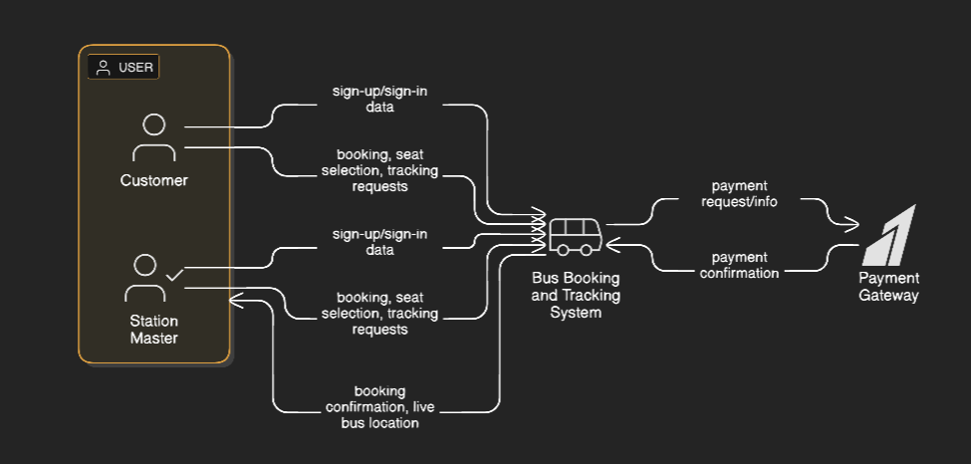
Fig. 4.4 DFD of MSRTC Bus Booking & Tracking System

4.5 Activity Diagram
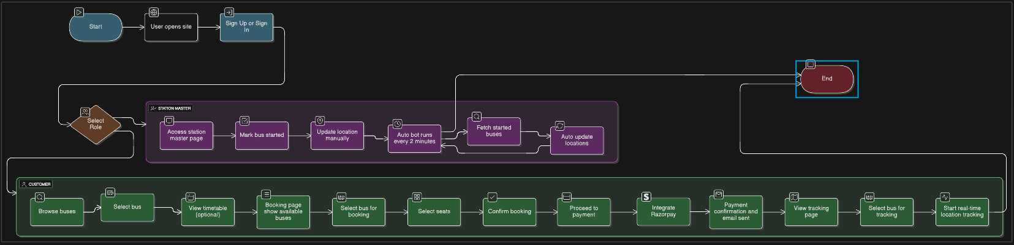
Fig. 4.5 Activity Diagram of MSRTC Bus Booking & Tracking System
Here are the actors in your bus booking and tracking system along with their roles:
- Customer/User
  - Registers and logs into the system.
  - Searches for available buses.
  - Selects buses and seats.
  - Makes online payments for bookings.
  - Tracks live bus locations in real-time.
  - Receives booking confirmation emails.
- Station Master
  - Logs into the system.
  - Marks buses as started.
  - Updates bus GPS locations manually.
  - Monitors buses under their control.
  - Supports real-time bus tracking by providing location updates.
- Automated Bot (AutoStationMasterBot and Selenium Bot)
  - Periodically fetches started buses from the system.
  - Automatically updates bus location data to backend.
  - Reduces manual effort by station masters.
  - Ensures frequent and accurate real-time location updates.
- Payment Gateway (Razorpay)
  - Handles payment transactions initiated by users.
  - Confirms payment status to the system.
  - Facilitates secure and seamless money transfer.

Chapter 5
System Implementation

5.1 Module Description

5.1.1 Authentication Module :
  - Register new users with role assignment (customer or station master).
  - User login verification and session management.
  - Role-based access control to different system features.
5.1.2 Bus Selection & Booking Module :
  - Display available buses with details including bus name, type, and timings.
  - Show seat map for each bus with real-time seat availability.
  - Support seat selection and booking confirmation.
  - Manage booking data and store user selections.
5.1.3 Payment Module :
  - Calculate fare based on the number of seats selected (₹150 per seat).
  - Integrate Razorpay gateway for secure payment processing.
  - Display payment QR code or options.
  - Confirm payment status and capture successful transactions.
  - Handle payment failures or retries gracefully.
5.1.4 Notification Module :
  - Automatically send confirmation emails after successful booking and payment.
  - Provide booking details including bus info, seat numbers, and payment receipt to users.
5.1.5 Station Master Module :
  - Allow station masters to mark buses as started.
  - Enable manual GPS location updates for buses.
  - View and manage buses under their control.
5.1.6 Tracking Module :
  - Enable users to input bus details and check current live bus location.
  - Periodically fetch and display real-time GPS data.
  - Show bus location updates on a map interface for tracking.

5.2 Data Set Collection
- The project uses a sample dataset created by the user, named "msrtc_bus_data_sample.csv," containing bus-related attributes such as bus_name, bus_type, bus_start_time, and other relevant fields.
- This CSV dataset has a size of approximately 1944 bytes and consists of around 40-50 records (rows) representing different buses and their respective details.
- For the mini project scope, seat and booking information are dynamically managed on the server side using dictionaries, supporting real-time booking and seat availability tracking without a complex database.
- This simple data setup aligns well with the project’s focus on functional demonstration of booking, payment, location updating, and tracking features.

5.3 Pseudocode and Screenshot
5.3.1 Pseudocode of MSRTC Bus Booking and Tracking System
# SYSTEM INITIALIZATION
START System
LOAD bus data from msrtc_bus_data_sample.csv
INITIALIZE:
users = {} # User details by email
bookings = {} # Booking info by bus and seat
seat_maps = {} # Seat status by bus
bus_locations = {} # Location info by bus
started_buses = set()
CONFIGURE Razorpay and Email

# AUTHENTICATION MODULE
FUNCTION register_user(email, password, name, role):
IF email not in users:
users[email] = {name, password, role}
RETURN success
ELSE:
RETURN error (Duplicate email)

FUNCTION login_user(email, password):
IF email in users AND users[email].password == password:
CREATE session with email, role
RETURN login success
ELSE:
RETURN login failure

# BUS SELECTION & BOOKING MODULE
FUNCTION fetch_available_buses():
READ and DISPLAY buses from CSV
FUNCTION show_seat_map(bus_key):
DISPLAY seat layout from seat_maps[bus_key]

FUNCTION select_and_book_seats(user, bus_key, seat_numbers):
IF all seats in seat_numbers are available in seat_maps[bus_key]:
FOR each seat in seat_numbers:
seat_maps[bus_key][seat] = user
bookings[(user, bus_key)] = seat_numbers
RETURN booking success
ELSE:
RETURN error (Seat(s) already booked)

# PAYMENT MODULE
FUNCTION calculate_fare(seat_numbers):
RETURN len(seat_numbers) * 150

FUNCTION initiate_payment(user, amount):
ORDER = Create Razorpay order for amount
SHOW payment QR code or online gateway
FUNCTION confirm_payment(payment_id):
STATUS = Verify payment with Razorpay
IF STATUS == successful:
UPDATE booking as confirmed
CALL send_confirmation_email(user)
RETURN payment success
ELSE:
RETURN payment failure

# NOTIFICATION MODULE
FUNCTION send_confirmation_email(user):
COMPOSE and SEND booking+payment details to user.email

ON payment success:
CALL send_confirmation_email(user)

# STATION MASTER MODULE
FUNCTION login_station_master(email, password):
IF role == station_master:
GRANT dashboard access

FUNCTION mark_bus_started(bus_key):
started_buses.add(bus_key)

FUNCTION manual_update_location(bus_key, lat, lon):
bus_locations[bus_key] = (lat, lon, CURRENT_TIMESTAMP)

# AUTOMATED BOT MODULE
LOOP every X minutes:
FOR bus_key in started_buses:
location = GET location (from API/device/simulation)
bus_locations[bus_key] = (lat, lon, CURRENT_TIMESTAMP)

# TRACKING MODULE
FUNCTION track_bus_location(bus_key):
LOOP while tracking:
latest_location = bus_locations.get(bus_key)
DISPLAY latest_location on map
SLEEP(refresh_interval)

# TIMETABLE MODULE
FUNCTION show_bus_timetable():
DISPLAY bus schedule from CSV

# MAIN USER FLOW
START system
DISPLAY homepage
USER selects Register or Login

IF Register:
CALL register_user
ELSE IF Login:
CALL login_user

IF role == customer:
CALL fetch_available_buses
USER selects bus (bus_key)
CALL show_seat_map(bus_key)
USER selects seat_numbers
CALL select_and_book_seats
CALCULATE fare and proceed to payment
CALL initiate_payment and confirm_payment
ON success:
DISPLAY booking and enable live tracking
USER can call track_bus_location

IF role == station_master:
ACCESS dashboard
CALL mark_bus_started(bus_key) as needed
MANUALLY update location per bus
SYSTEM/automated bot also updates bus_locations
# END SYSTEM
5.3.2 Screenshots

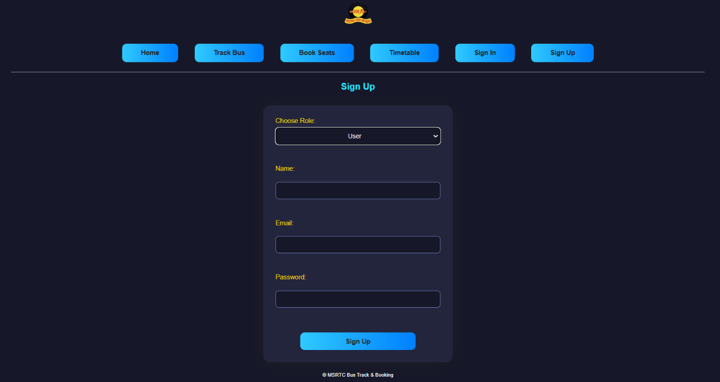
Fig. 5.3.2.1 Sign up page of MSRTC Bus Booking & Tracking System

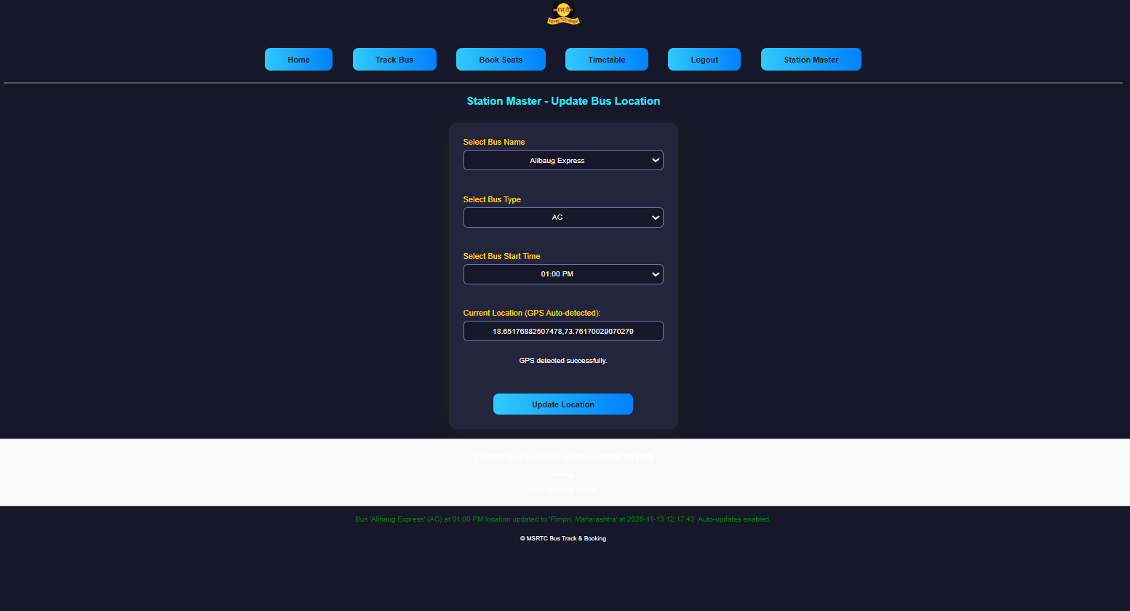
Fig. 5.3.2.2 Admin location update page of MSRTC Bus Booking & Tracking System

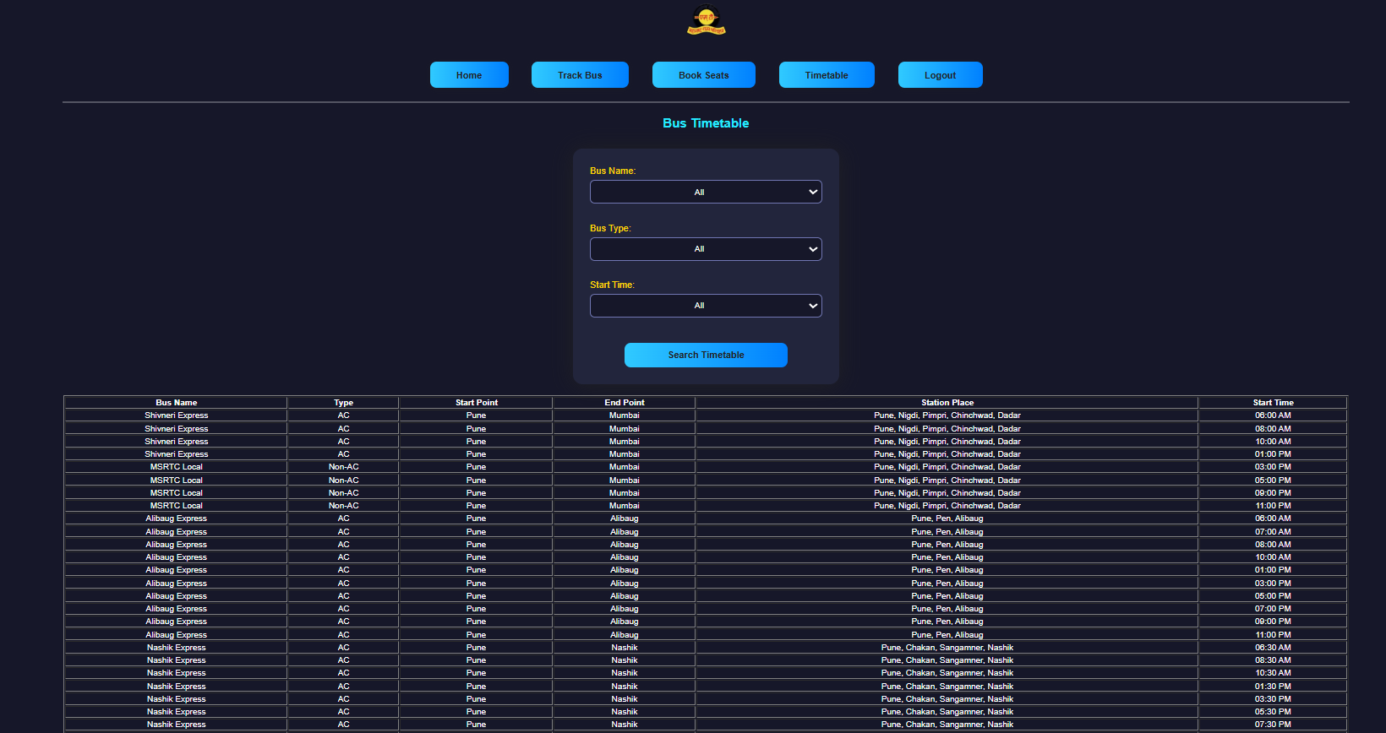
Fig. 5.3.2.3 Timetable page of MSRTC Bus Booking & Tracking System

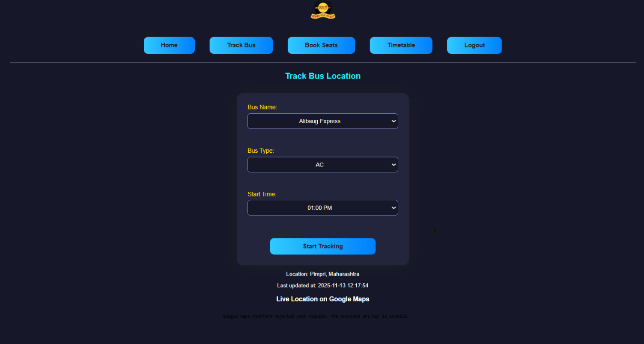
Fig. 5.3.2.4 User interface tracking page of MSRTC Bus Booking & Tracking System

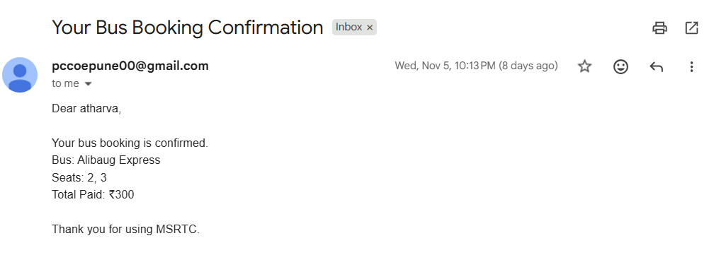
Fig. 5.3.2.5 Seat conformation mail after booking on seat booking page of MSRTC Bus Booking & Tracking System

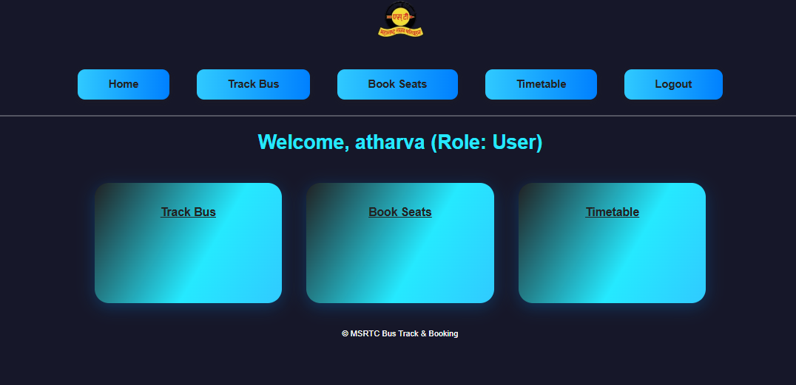
Fig. 5.3.2.6 User interface home page of MSRTC Bus Booking & Tracking System

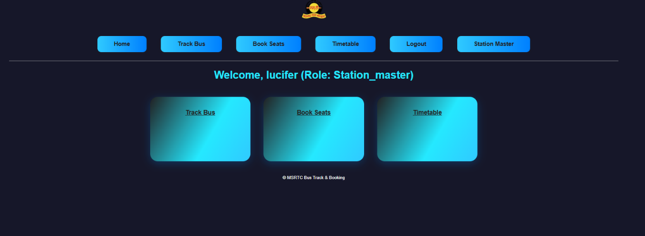
Fig. 5.3.2.7 Admin interface page of MSRTC Bus Booking & Tracking System

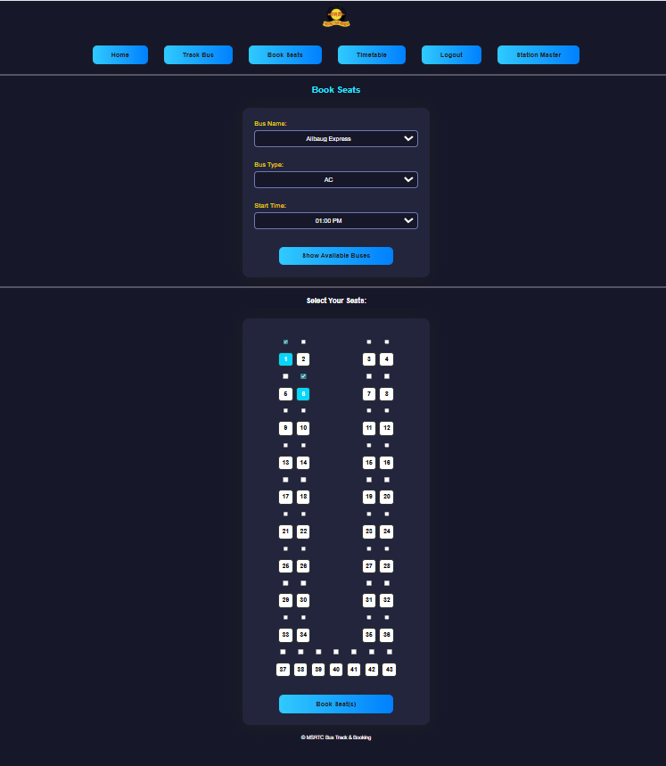
Fig. 5.3.2.8 Seat booking page of MSRTC Bus Booking & Tracking System

Chapter 6
Testing and Deployment
6.1 Manual Test Cases Table (Sample)
Test ID | Input | Expected Output | Actual Output | Result
TC-01 | Register with all valid info | User registration successful | Success | Pass
TC-02 | Book 2 seats and pay | Email and booking confirmation | Email sent | Pass
TC-03 | Book an already-booked seat | Error: Seat already booked | Error shown | Pass
TC-04 | View seat map updates on booking | Seat turns red (booked) instantly | Seat disables | Pass
TC-05 | Station Master updates location | Users see new bus location on track | Status updates | Pass
TC-06 | Register with existing email | Error: User already exists | Error shown | Fail
TC-07 | Pay with invalid payment ID | Error: Payment failed | Payment error message | Fail
TC-08 | Book seat without selecting bus | Error: Bus not selected | Error shown | Fail
TC-09 | Track bus with no GPS update | Error: Location not available | Location error | Fail

6.2 Deployment
- Project runs using Python (Flask) on localhost or college server
- Static files and templates served via Flask; dataset MSRTC CSV in root
- No sensitive data is hard-coded; app passwords managed securely

Chapter 7
Result and Discussion

7.1 Result
- The project successfully delivers an interactive MSRTC web platform for seat booking and UPI payment, enabling users to secure seats online for public buses with ease.
- Confirmation emails are reliably sent to users immediately after booking and payment, providing all necessary travel details and digital proof.
- The system incorporates a live seat chart—any seat booked turns red/disabled in the interface—preventing booking conflicts, double bookings, and improving booking accuracy.
- It is responsive and mobile-view friendly, supporting real-time bus location updates via station master's input, ensuring passengers and staff always have the latest route info.
- All core modules (authentication, selection, payment, tracking, notification, admin location update) functioned as expected in manual testing and sample cases.

7.2 Discussion
- The platform replaces traditional, time-consuming ticket counters with a digitized workflow, streamlining both user experience and backend operations.​
- By using server-side dictionaries and CSV files for bookings, seats, and bus schedules, the project remains lightweight yet covers the essential logic for a scalable transport solution.
- Email notifications and live seat maps were most effective in reducing uncertainty and confusion during peak times; both features contributed to improved passenger satisfaction and reduced operational errors.
- Mobile compatibility and real-time bus tracking via manual/admin updates and future bot systems set a technical precedent for MSRTC and similar agencies aiming for digital transformation.​

7.3 Future Scope
- Integrate SMS alerts for bookings and updates so users receive instant notifications beyond email.
- Move data storage and core logic to cloud infrastructure for real-time syncing, better scalability, and enhanced fault tolerance.
- Add advanced admin analytics dashboards (for operators), leveraging passenger, payment, and route data to optimize resources, pricing, and scheduling.​
- Enable GPS-based fully-automated tracking for buses, reducing reliance on manual updates and empowering more advanced passenger information systems.
- Broaden payment options with card, wallet, and direct bank transfer support, improving accessibility for all users.
- Implement multi-language support, helping non-English speaking travelers engage with MSRTC digital services.

7.4 Conclusion
This mini-project demonstrates a digital ticketing, payment, and tracking system that meets the real-world needs of Indian bus passengers and administrators, replacing paper-based and manual workflows with a flexible, user-friendly, and transparent web platform. Its modularity, live features, and scope for expansion align with ongoing digitization initiatives, positioning it as a foundation for broader MSRTC digital upgrades and future smart transport systems.​

Chapter 8
References

- Pressman, R. S. Software Engineering: A Practitioner's Approach, McGraw-Hill.
- Sommerville, I. Software Engineering, Pearson Education.
- Flask Documentation: https://flask.palletsprojects.com/
- MSRTC Official site: https://msrtc.maharashtra.gov.in/
- United Nations SDG: https://sdgs.un.org/goals/goal11

